Experiment No. 7

You are given two tables: *Students* and *Grades*. *Students* contains three columns *ID*, *Name* and *Marks*.

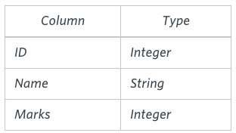

*Grades* contains the following data:

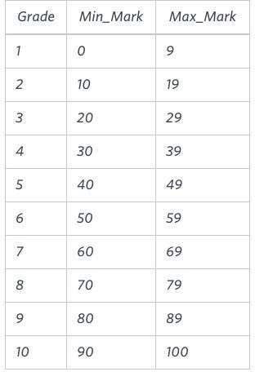

*Ketty* gives *Eve* a task to generate a report containing three

columns: *Name*, *Grade* and *Mark*. *Ketty* doesn't want the NAMES of those students who received a grade lower than *8*. The report must be in descending order by grade -- i.e. higher grades are entered first. If there is more than one student with the same grade (8-10) assigned to them, order those particular students by their name alphabetically. Finally, if the grade is lower than 8, use "NULL" as their name and list them by their grades in descending order. If there is more than one student with the same grade (1-7) assigned to them, order those particular students by their marks in ascending order.

Write a query to help Eve.

**Objective:** To extract data from relations using CASE and analyse the results

Solution:

create table students( id int, name varchar(100), marks int);

insert into students values (1,'Julia', 88);

insert into studentsvalues (2,'Samantha', 68);

insert into students values(3,'Maria', 99);

insert into students values(4,'Scarlet', 78);

insert into students values(5,'ashley', 63);

insert into students values(6,'James', 81);

insert into studentsvalues (7,'Roy', 44);

Select*from students;

create table grades(grade int,Min_mark int,Max_Mark int);

insert into grades values (1,0,9);

insert into grades values (2,10,19);

insert into grades values (3,20,29);

insert into grades values (4,30,39);

insert into grades values (5,40,49);

insert into grades values (6,50,59);

insert into grades values (7,60,69);

insert into grades values (8,70,79);

insert into grades values (9,80,89);

insert into grades values (10,90,100);

Select*from grades;

SELECT CASE

WHEN Grades.Grade < 8 THEN 'NULL'

ELSE Students.Name

END

, Grades.Grade, Students.Marks

FROM Students, Grades

WHERE Students.Marks >= Grades.Min_mark AND Students.Marks <= Grades.Max_mark

ORDER BY Grades.Grade DESC, Students.Name;